EMPOWER captures the major findings from a wide set of research into effective teaching and learning, cognitive science, educational psychology, development of expertise, motivation and optimal experience, etc.

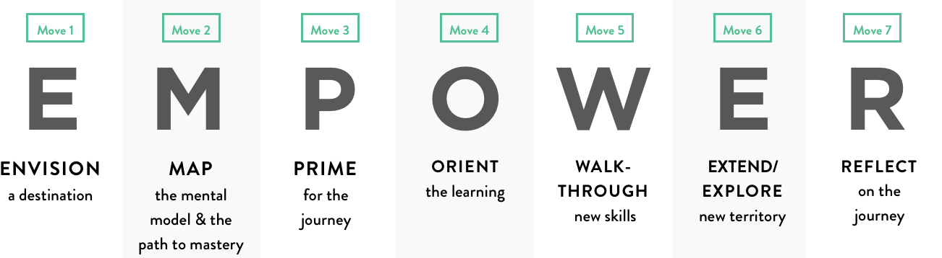

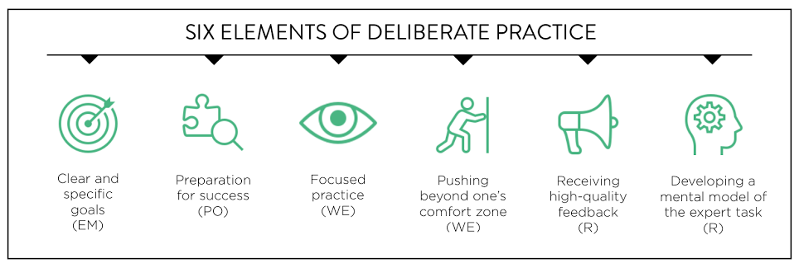

Here is the pattern of apprenticeship-style teaching, captured by EMPOWER:

Offstage, effective educators ENVISION a destination for learners and then MAP out each step of the journey, including the knowledge, tools, and mental models (strategy) required for achievement of mastery.

Once onstage, educators build motivation PRIME students by activating and building background knowledge and ORIENT them towards the new destination: a learning outcome phrased in terms of what students will be able to do independently by the close of the unit.

With motivation built, students now require mentorship. At this point, educators WALKTHROUGH new skills and concepts and engage students in extending their expertise in a variety of guided and collaborative practice tasks that increase in challenge/complexity and decrease in scaffolding/support over time. This is the time for modeling, coaching, and feedback as students rehearse, practice, and scrimmage. They are purposeful, contextualized, lower stakes learning experiences that exist to develop students’ abilities.

With their skills and knowledge built, it is then time for students to put their learning to the ultimate test. Educators challenge students to EXPLORE new territory and EXTEND all capacities, transferring what has been learned into a novel situation that presents the possibility of failure. This is very much like the “call to action” found in the hero’s journey, the build-up to the “big game” in sports, or an opening night performance in the arts.

At this point, though, the educator is in the audience or on the sidelines. Their job is to step back and let students triumph or struggle without assistance, else they will never learn how to independently apply what has been taught.

Throughout this entire process and especially at the end, with the big game, opening night performance, or dragon slaying behind us, we collectively REFLECT. What was learned and how? Why is it important and how does it connect to our future goals? How can we use it now and in the future? What are our individual and collective strengths and struggles? EMPOWER is not a formula, it is a mental map – a mental model and representation of how to complete a complex task
From PLANNING POWERFUL INSTRUCTION: 7 MUST MAKE MOVES TO TRANSFORM HOW WE TEACH – AND STUDENTS LEARN, Grades 2-5 and 6-12 versions, Wilhelm, et al, Corwin Publishers 2022

